Assignment 1

____________________________________________________

COS 20019- Cloud Computing Architecture

Nguyen Manh Dung

5/6/2023

So this is all my step to finish Assignment 1, comes with detailed screenshot explanation

1. This is the step that I captured to show how can I connect remote access by puttygen
2. So I created a new keypair and save it as .pem file. Then I use puttygen to generate it to .pkk file, as shown in screenshotted.

I also create a new security group to match with requirement.

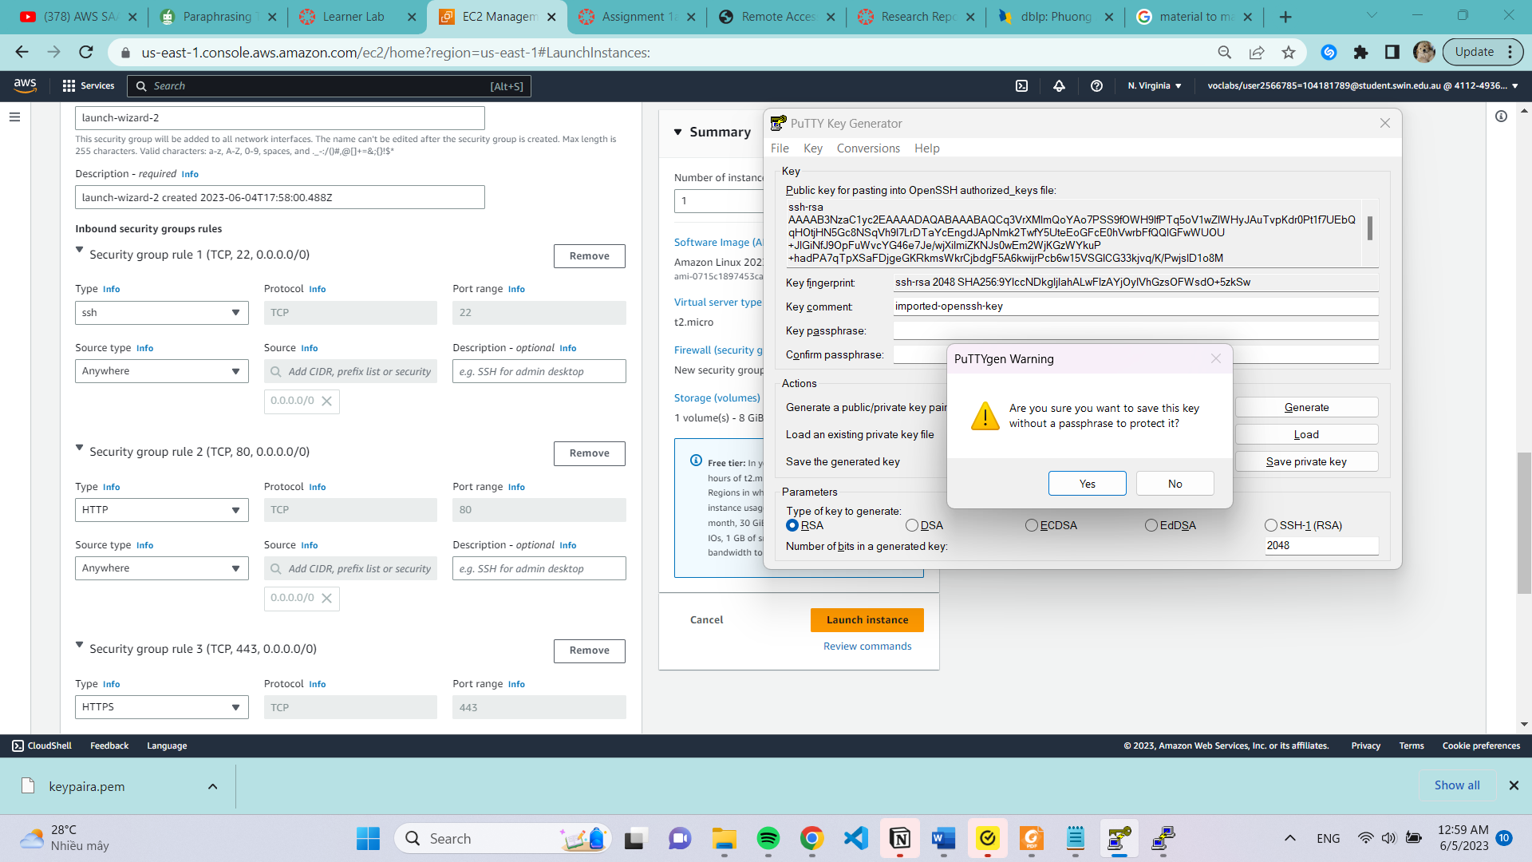

For advance details, I copied source code then paste back to User data site.

So this is my new instance that I’ve created.

1. Then next step is to connect server instance by Putty
2. Launch PuTTY and enter your EC2’s public DNS as the host name.

- Navigate to Connection | SSH | Auth then click ‘Browse’ to select the .ppk private key file

exported from PuTTygen above.

- Navigate to Connection, then put a number other than 0 in ‘Seconds between keepalives’

field to maintain the connection to EC2 and avoid being dropped out.

1. Click open so now you will be able to interact with your Linux EC2 instance via the terminal.

1. Next is to make Linux instance can exchange files with WinSCP.
2. Launch WinSCP. In the promted Login dialog box, enter your EC2’s public DNS as the host

name and ec2-user as the user name. File protocol is SFTP.

- Click ‘Advanced…’ then navigate to SSH – Authentication.

- Select your private key file (.ppk) then hit ‘OK’.

- Click ‘Login’. Now you can start transfer files with your Linux EC2 instance

So I’ve made Linux able to exchange file with WinSCP, screenshot below is the step that I create a php files and

1. And this is final output

